Chicken with caramelized onions and croutons
2/13/2019
Made this with potatoes thinly sliced along with onions. Onions did not caramelize. Chicken thighs were rubbery and I probably left them in the oven. Still not bad. Croutons from sliced bread dipped in olive oil and added to oven. Ayumi liked the potatoes and croutons and chicken. Shinji liked the chicken. super easy to prepare.
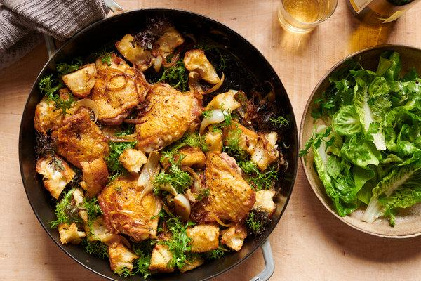
https://cooking.nytimes.com/recipes/1019993-chicken-with-caramelized-onions-and-croutons
This is a no-recipe recipe, a recipe without an ingredients list or steps. It invites you to improvise in the kitchen.
This idea came to me from the great New York Times food reporter Julia Moskin. Scatter a bunch of sliced onions and shallots across the oiled bottom of a large pan, then put a bunch of chicken thighs on top, skin-side up. Season the thighs with salt and pepper, then slide the pan into a 425-degree oven to roast until the chicken is crisp on top and cooked through, about 35 minutes. Shake the pan every so often, and add wine or stock if the onions are browning too fast. Meanwhile, make some croutons from good, chewy olive-oil-tossed bread, toasting them until golden in a pan or in the oven alongside the chicken. They can be cut or torn up — no matter. Put the croutons on a warm platter, dump the contents of the roasting pan over the top and arrange the chicken on top of that, mixed with bitter greens. Boy howdy.

